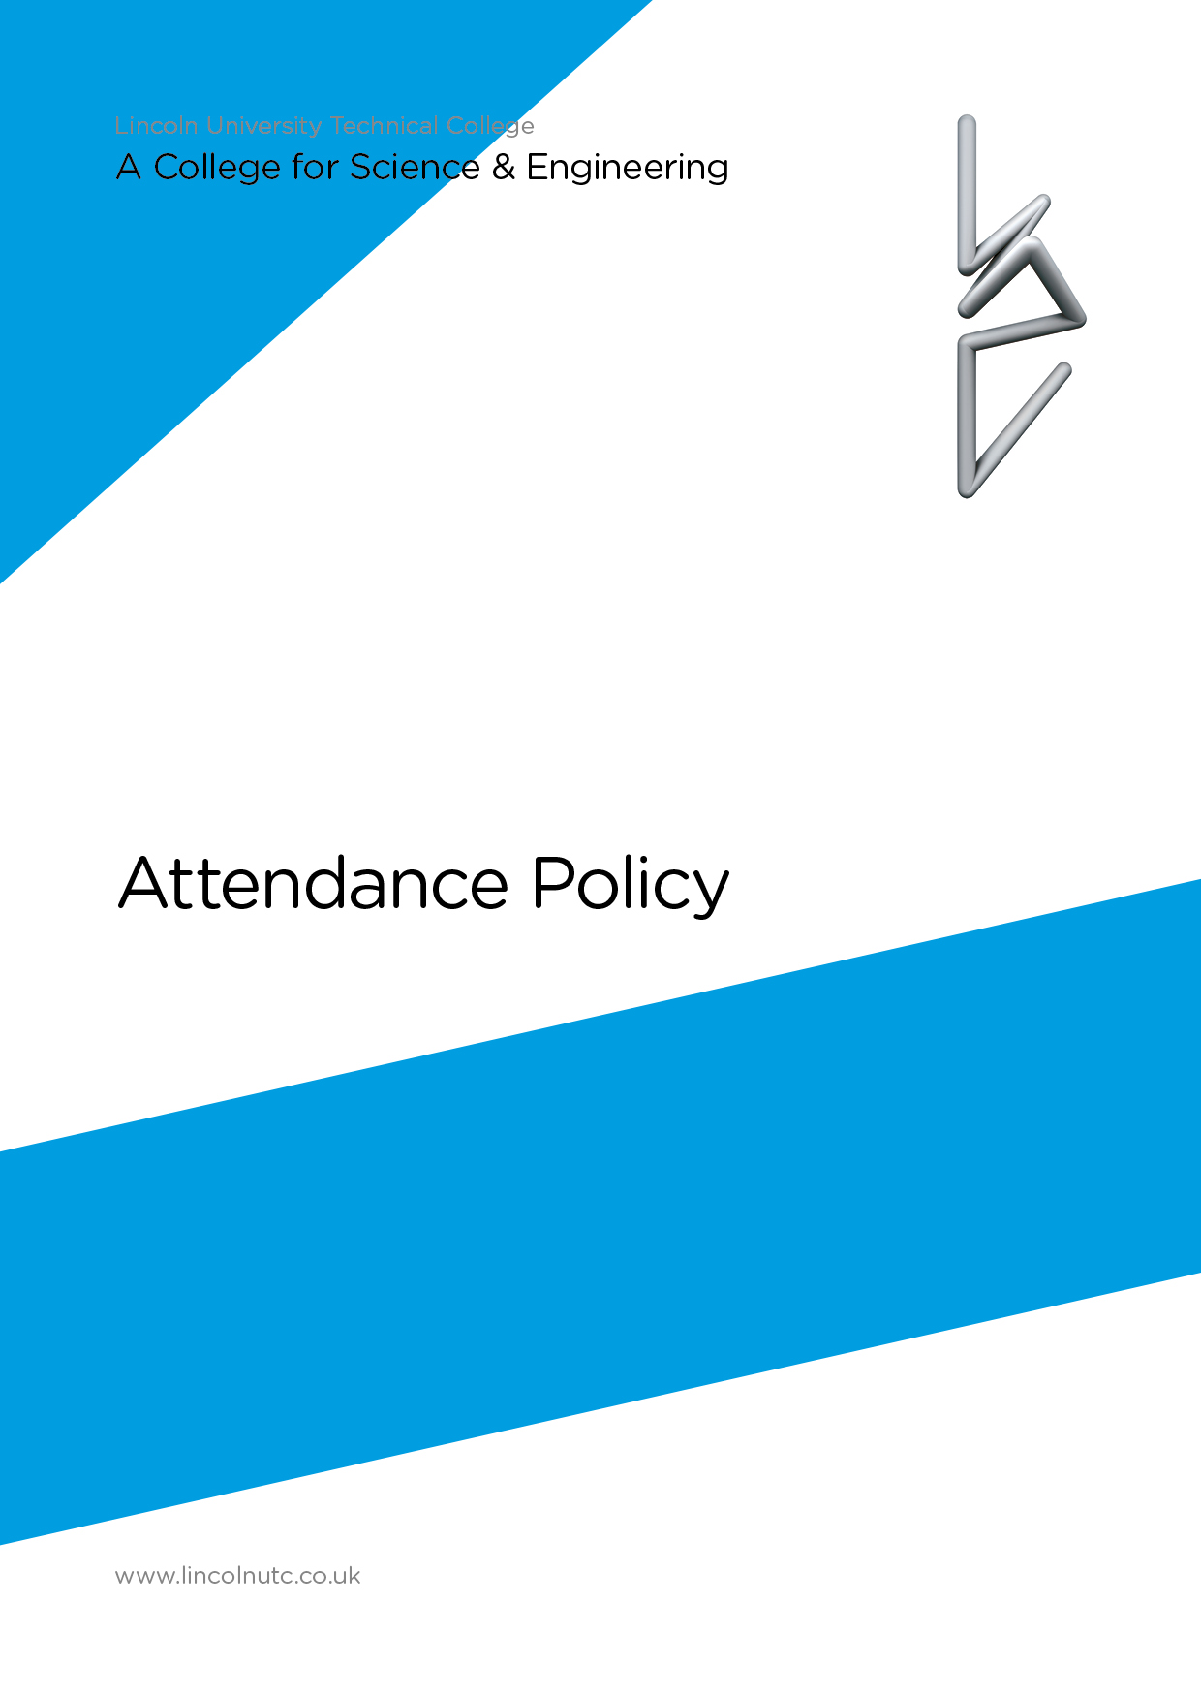

Equality and Diversity Statement

Lincoln UTC strives to treat all its members and visitors fairly and aims to eliminate unjustifiable discrimination on the grounds of gender, race, nationality, ethnic or national origin, political beliefs or practices, disability, marital status, family circumstances, sexual orientation, spent criminal convictions, age or any other inappropriate grounds.

Lincoln UTC

attendance policy

CONTENTS

Para | Contents
1 | Introduction
2 | Legislation regarding student attendance
3 | Responsibilities:
 | - Parent/carers’ Responsibilities
 | - Students’ Responsibilities
 | - Pastoral Lead Responsibilities
 | - Teaching Staff Responsibilities
- Mentors Responsibilities
- Leadership Team responsibilities
4  5 | Attendance codes  Late arrivals
6 | Leave of Absence for Family Holidays/Extended Trips Overseas and penalties
7 | External Interventions for unacceptable attendance

Lincoln UTC

attendance policy

1. Introduction

In managing student attendance, we will operate in line with the government legislation - ‘2006 Pupil Registration Regulations and the DfE document ‘School attendance - policy and practice on categorisation of absence’.

Students need to demonstrate excellent attendance at Lincoln UTC so that they are able to take full advantage of the educational opportunities that we provide. Statistics support that excellent attendance links to increased attainment.

As staff we will all work together to encourage maximum attendance by:

- sharing high expectations of all our students;
- creating a caring and secure atmosphere in which students feel valued;
- providing a stimulating and accessible curriculum;
- providing an attractive and safe environment;
- supporting students if they have problems or concerns;
- working closely with parents/carers;
- ensuring we adhere to the UTC’s systems for ensuring good attendance and punctuality.

2. Legislation AND GUIDANCE regarding attendance

- The Education (Pupil Registration) (England) Regulations 2006
- Education (Pupil Registration) (England) (Amendment) Regulations 2013
- The Education (School Attendance Targets) (England) Regulations 2007
- The Education (School Attendance Targets) (England) (Amendment) Regulations 2010
- School attendance Guidance for maintained schools, academies, independent schools and local authorities
- September 2018
- Children Act 2004
- The Education Act 2002
- Crime and Disorder Act 1998
- School Standards and Framework Act 1998
- Anti-social Behaviour Act 2003.

3. ResponsibilitIES

Parents/Carers’ Responsibilities
Parents/carers are legally responsible for ensuring their child’s regular and punctual attendance, and that their child is fully equipped and in appropriate Lincoln UTC attire.

Parents/carers are responsible for immediately informing Lincoln UTC of the reason for their child’s absence and an indication of when the child might return to the UTC. If a child is ill, we ask that the parent / carer rings or email the UTC on the first day of absence by 8.30am. The phone number is 01522 775990.

If the parent does not ring the UTC this will be recorded as an unauthorised absence. The UTC expects parents/carers to provide a justifiable reason for absence. We request that the child is not allowed to remain at home for minor complaints or illnesses.

If student absence is related to matters other than illness the parent/guardian should contact their child’s Mentor, Head of Key Stage or the Receptionist who will take immediate action.

Students’ Responsibilities

Students must ensure they attend the UTC regularly and arrive to sessions on time.

Students must NOT leave the UTC without permission.

Students who have been absent must ensure parent/carers have advised the UTC of the reason for absence by letter or email. Parents/carers who have not advised the UTC will be contacted.

Students may be invited to attend a ‘return to learn’ meeting with their Mentor on the first day following an absence lasting for longer than three days: any concerns will be discussed and suitable support offered.

If students arrive at the UTC late, they must sign in at reception and provide a full explanation for their lateness. If they have attended an appointment, without prior notice, they should provide evidence of this. If they need to leave the UTC for an appointment they must have a note or appointment card and sign out at Reception.

Pastoral Lead Responsibilities

The Pastoral Leaders are available during UTC hours to discuss any attendance concerns, providing support to students and parents/carers.

Mentors will ensure that online registration is conducted promptly during mentoring sessions on Monday and Friday and also during period 1 on Tuesday, Wednesday and Thursday. This is a legal requirement. Heads of Key Stage will support Class Mentors with attendance or late issues. All parents/carers of students for whom we have no reason for absence will be contacted.

If the parent/carer does not report a reason for absence, the Head of Key Stage will contact parents.
Records of any reasons for absence, attendance concerns (e.g. illness/medical appointments and class truancy) and any interventions put in place will be kept and monitored on an individual basis. A weekly statistical return will be forwarded to Mentors and the Pastoral Lead. Other printouts, e.g. for an individual student, can be provided on request. Mentors will receive termly percentage attendance reports of individual students in their mentoring group and will support the pastoral lead following up with students where there are concerns.

The Behaviour and Attendance Officer or Head of Key Stage will regularly analyse student absence and look for patterns of absence, taking swift action where there is an attendance concern. Students with attendance issues will be followed up immediately. Students whose percentage attendance falls below 95% will be reviewed regularly by the Head of Key Stage and the Attendance Officer. Following this review contact home will be made.

The Behaviour and Attendance Officer or Head of Key Stage will liaise regularly with parents/carers and external agencies about current student attendance concerns and will represent Lincoln UTC at local authority attendance meetings and other multiagency meetings.

Mentor Responsibilities

Morning mentor session / registration

All mentors must complete a register of attendance on Management Information System. This is a legal requirement. Mentors must be fully aware of the travel plans of their mentees and ensure that students arrive promptly to the UTC in line with their travel arrangements. It is not acceptable for students to delay arrival until 8.45am unless they have a valid travel plan reason.

Afternoon registration – Lesson 6

Students will be registered after lunch within the first 10 minutes of period 6 by their subject teacher.

Any discrepancies (i.e. present at registration but not in lesson) should be reported to the Attendance Officer as soon as possible to be followed up. If a student is absent long-term, all teaching staff must provide appropriate work as requested by the Head of Key Stage.

The Mentor is responsible for the daily review of their students’ Management Information System record and liaising with students. Any update on attendance will be e-mailed promptly to the Pastoral Lead as necessary. The Mentor will sanction late students in line with the behaviour policy.

If a Mentor has concerns about a student’s absence, they must inform the Pastoral Lead. It is essential that swift action is taken to investigate absence, especially where a problem is highlighted or no explanation from parents/carers is provided.

Students Out of Lincoln UTC

If students are out of Lincoln UTC on a visit or trip a register must be taken prior to departure and a copy left on reception. This register will then be entered into Management Information System by administration staff.

Leadership Team Responsibilities

Members of the Leadership Team will support the Behaviour and Attendance Officer as necessary. A member of the Leadership Team will have the responsibility of overseeing attendance issues and regularly liaise with Heads of Department, the Behaviour and Attendance Officer and the Education Welfare Service.

4. ATTENDANCE CODES

Authorised absence

- present (am / pm) / \
- educated off-site (B)
- dual registered (D)
- exclusion – no alternative provision (E)
- family holiday authorised (H)
- extended family holiday (authorised) (F)
- attending an interview (J)
- illness (I )
- approved sporting activities (P)
- study leave (S)
- educational visit (V)
- work experience (W)
- unable to attend due to exceptional circumstances (Y)
- not required to be in (X)
- pupil not on admission register (Z)
- planned part or whole closure (#)
- medical/dental appointment (M)
- religious observance (R)

Unauthorised absence

- late (L)
- reason for absence not yet provided (N)
- family holiday not authorised or in excess of agreed period (G)
- absent without authorisation (O)
- traveller absence (T)
- arrived after registration closed (U)

The Pastoral Liaison Officer may occasionally use:

- other authorised circumstances (C)

Unauthorised Absences

When a student is absent without prior authorisation and no justifiable reason for the absence is provided, the absence is classed as unauthorised.

Some families will undoubtedly experience unusual and unavoidable situations (e.g. a sudden death of a relative) and we will be sympathetic in such circumstances. However, if a student is frequently late or absent because of their family situation, the reasons for this must be investigated and such absences may not be authorised.

N.B. If a Mentor has any doubt about the reason given for absence, feels that a parent may be condoning an unjustified absence or that a note or phone call is not authentic, they must consult the Behaviour and Attendance Officer who will investigate.

5. Late ARRIVALS

Punctuality is critical as we prepare our students for the world of work. If a student arrives after 8:45am this will be recorded on Management Information System. Late students will report to the reception and sign in the late book.

If a student is late due to a medical appointment, evidence must be provided. The lateness will then be authorised.

Consequences

Students who arrive late without a satisfactory explanation will receive a negative entry on their Management Information System record by the Receptionist and this is monitored by the Behaviour and Attendance Officer. This will have an impact on the upcoming opportunities available to them. Further sanctions may be used to deter lateness.

6. Leave of Absence for Family Holidays/Extended Trips Overseas and penaltieS

Continuity of learning is essential for a student to reach their full potential. Recent amendments to the Education (Pupil Registration) England Regulations 2006 confirm that Principals may not grant any leave of absence during term time unless there are exceptional circumstances. The Principal is to determine the number of days a student can be away from Lincoln UTC if the leave is granted. At the expectation of The Department for Education, Lincoln UTC will actively discourage leave in term time. A summary of these recent changes can be seen at

http://www.education.gov.uk/UTCs/pupilsupport/behaviour/attendance/a00223868/regulations-amendments

If a parent/carer is unable to avoid requesting absence during term time and wishes to seek a claim for absence under exceptional circumstances, an application must be made to the Principal at least six weeks before the absence is due to start.

Penalties for unauthorised holidays / other unauthorised absences

Unauthorised holiday may lead to the UTC requesting Education Welfare Service intervention, and a fixed penalty notice may be issued to each parent/carer with parental responsibility. A fixed penalty notice will be issued for each child i.e. a double fine where there are two siblings taking unauthorised leave. The level of penalty will be in accordance with the Education (Pupil Registration) England (Amendment) Regulations 2013 and can be seen at the web link listed above.

7. EXTERNAL Interventions for unacceptable attendance

If a student’s absence is persistent due to medical reasons the UTC may request documentation from the students doctor or hospital if there is an on-going condition: failure to provide this will mean the UTC will be unable to authorise further absence.

Failure to ensure a student attends regularly may result in the UTC making a referral to the Education Welfare Service who may request an attendance panel inviting students and parents to attend to discuss attendance issues. A legal attendance target may then be set. Failure to achieve this and if considered appropriate the Behaviour and Attendance Officer may issue a fixed penalty notice and could ultimately lead to prosecution.

The UTCs Behaviour and Attendance Officer may request an Acceptable Attendance Agreement in cases where students are known to the police. Breach of this may also mean a fixed penalty notice is issued and prosecution could also follow. Guidance for parents / carers can be found:

http://www.lincolnshire.gov.uk/parents/schools/welfare/

Policy reviewed: April 2019

